Student Studentington

Knowledge and Skill Portfolio

123 Main Street

Flint, Michigan 48506

810.555.1212

Student.Studentington@email.com

# Table of Contents

Table of Contents 2

Education 3

Experience 3

Skills 3

Activities 4

Degree Pathway: Computer Information Systems 5

College Transcript 6

Course Syllabi 7

Class Projects 8

Certifications 9

Student Engagement 10

Extra-curricular activities 11

|  |
| --- |
| Student Studentington  123 Main Street, Flint Michigan, 48506 · 810.555.1212  Student.Studentington@email.com |
| Seeking an entry level position as a computer support representative in a customer focused environment with room for advancement. |

# Education

|  |
| --- |
| Computer Information Systems, A.A.S., Mott Community College Maintaining 3.7 GPA while attending school. Classes focus on database design, computer programming with Python, C#, C++, PHP, MySQL, HTML5, CSS3, Network+ certification preparation, A+ certification preparation, IT customer support. Anticipated graduation date of May 2020. |
| Microsoft Technology Assocate Certification, Microsoft Earned Microsoft Technology Associate Certification 98-381 for Introduction to Programming: Python. This certification measures data types and operators, decisions and loops, input and output operations, documenting structured code, and error handling. A+ Certficiation, CompTia Earned CompTIA A+ 220-901 and 220-902 certifications validating PC hardware repair and computer configuration maintenance and support. |

# Experience

|  |
| --- |
| 01/2018 – 03/2019Cashier, Red Dot Store Assist customers in the in-store check-out process. Main duties include ringing up sales, bagging items, requesting price checks, honoring coupons, collecting payment and giving appropriate change. Displayed professionalism by never arriving late and always maintained a clean check-out area. |
|  |

# Skills

|  |  |
| --- | --- |
| * Programming with Python, C#, C++, PHP, MySQL, HTML5, CSS3 * Microsoft Office applications including Word, Excel, PowerPoint Access | * Windows operating systems * Computer repair/maintenance * Network configuration |

# Activities

|  |
| --- |
| * MCT Club: Computer technology club that created special computer builds, assisted with student tours/events at college, networked with other IT students. * Volunteerism: Volunteered at Mott Library Computer Lab assisting students with using computers for their college work. * Job Shadow: Job shadowed at XYZ Industry learning about roles within technical support. * College Presentations: Attended college presentations for Walsh College and UM-Flint for degree continuation programs to earn a bachelor’s degree. * IT Career Presentations: Attended various IT career presentations including a panel of graduates explaining how to go from being a student to being successful in IT, a presentation on large data within an academic organization, and how cloud computing is changing data storage needs. |

# Degree Pathway: Computer Information Systems



# College Transcript

# Course Syllabi

### COMS-170-01: Introduction to Programming, Summer 2019

**Overview:** This course taught the concepts of programming using the Python programming language including variables, conditions, lists, loops, exception handling, and functions. Program documentation also was covered for pseudo-code, flow charts (Raptor), and in-line documentation.

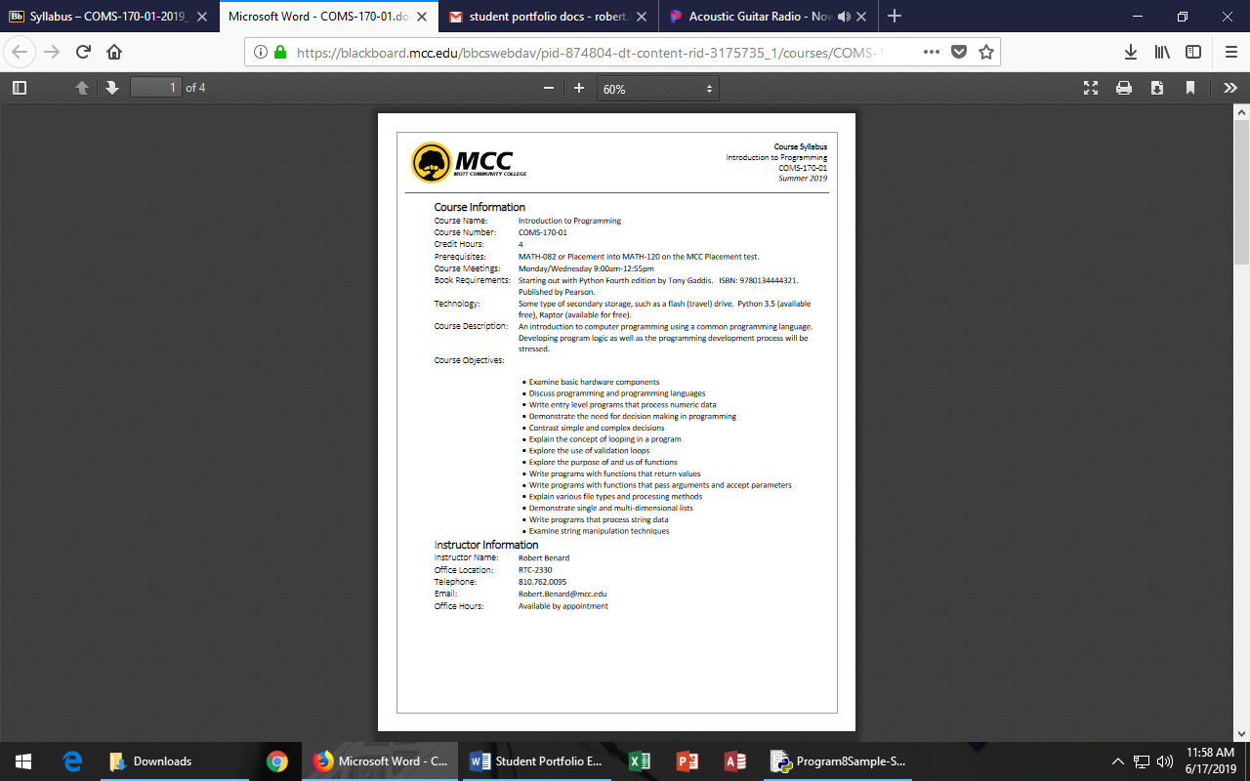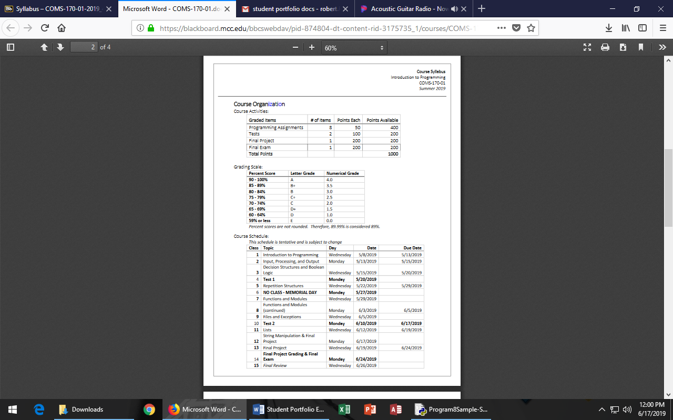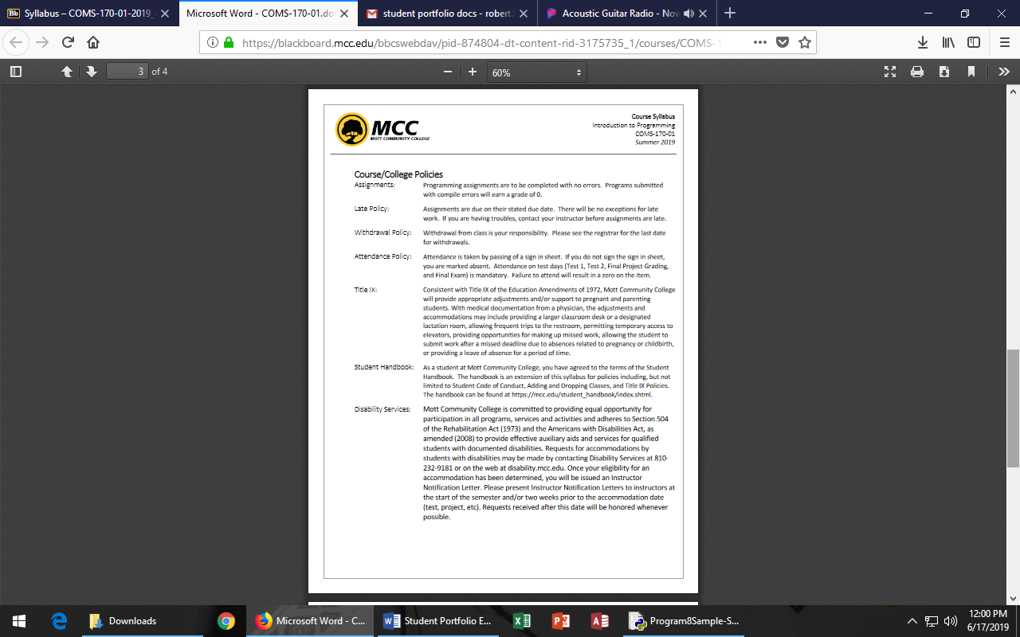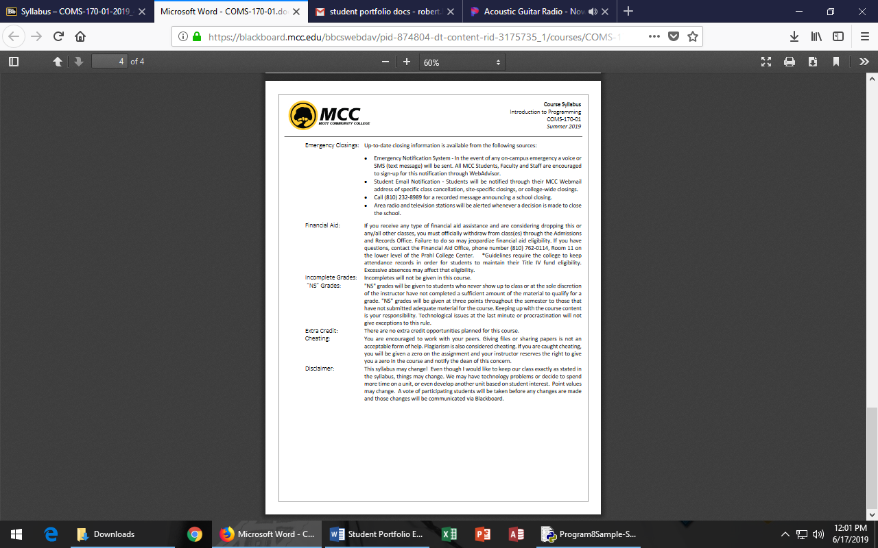

# Class Projects

**Course:** COMS-170 Introduction to Programming

**Programming Project:** Compute and display information relating to moving truck rental. For a specified customer, the program will compute and display the amount of money charged the customer’s truck rental.

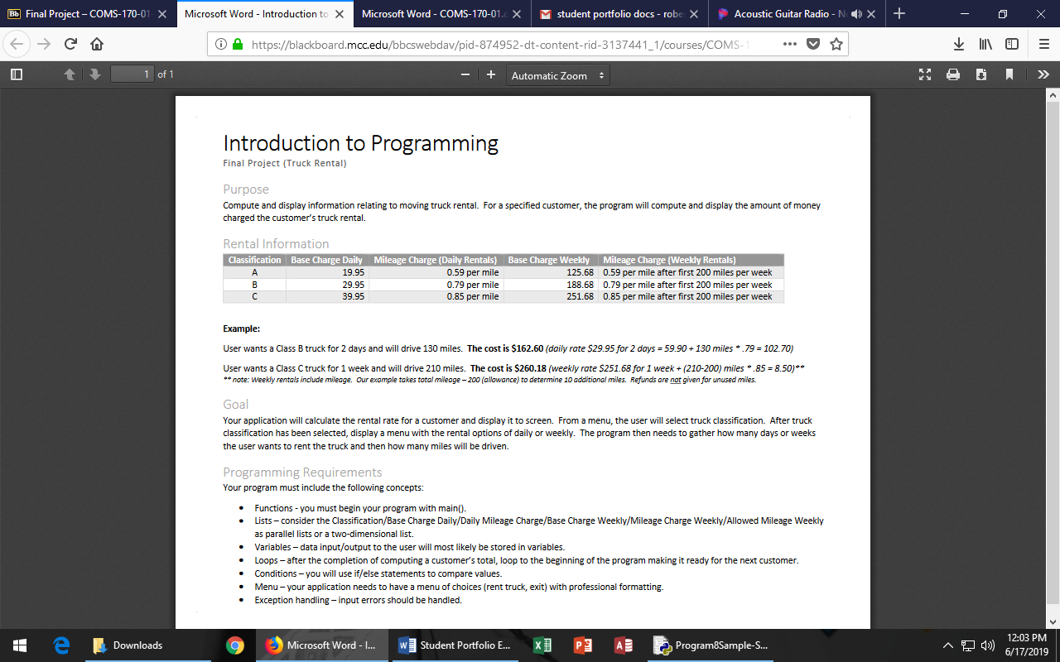

**User Interface:** The following screens identify the user interface for this application.

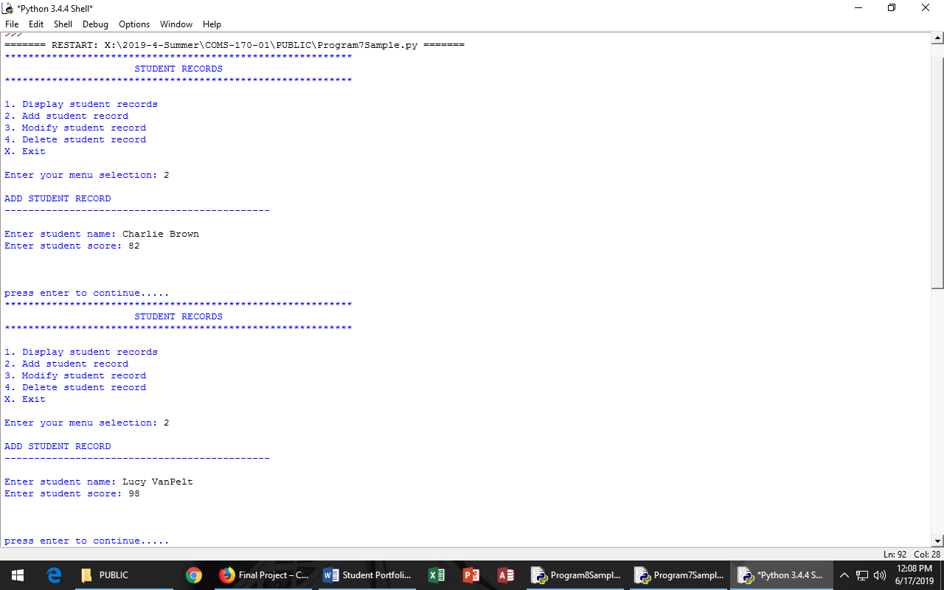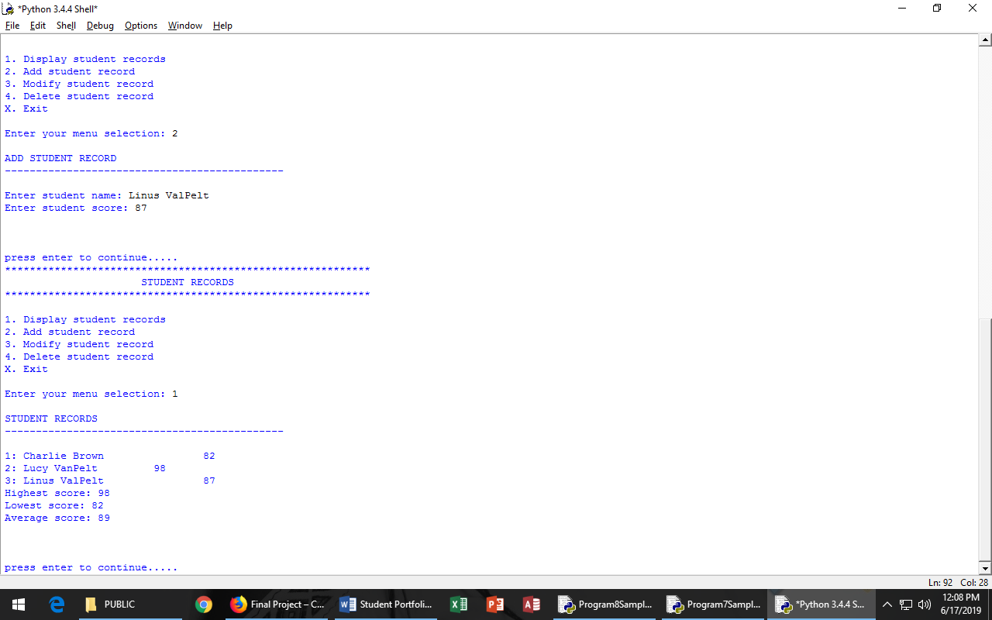

**Lessons Learned:** This project challenged me to work with parallel lists and functions in Python. I found that once the foundation was built, changing data was quite easy.

**Code:** The following are screen shots of my code for this application.

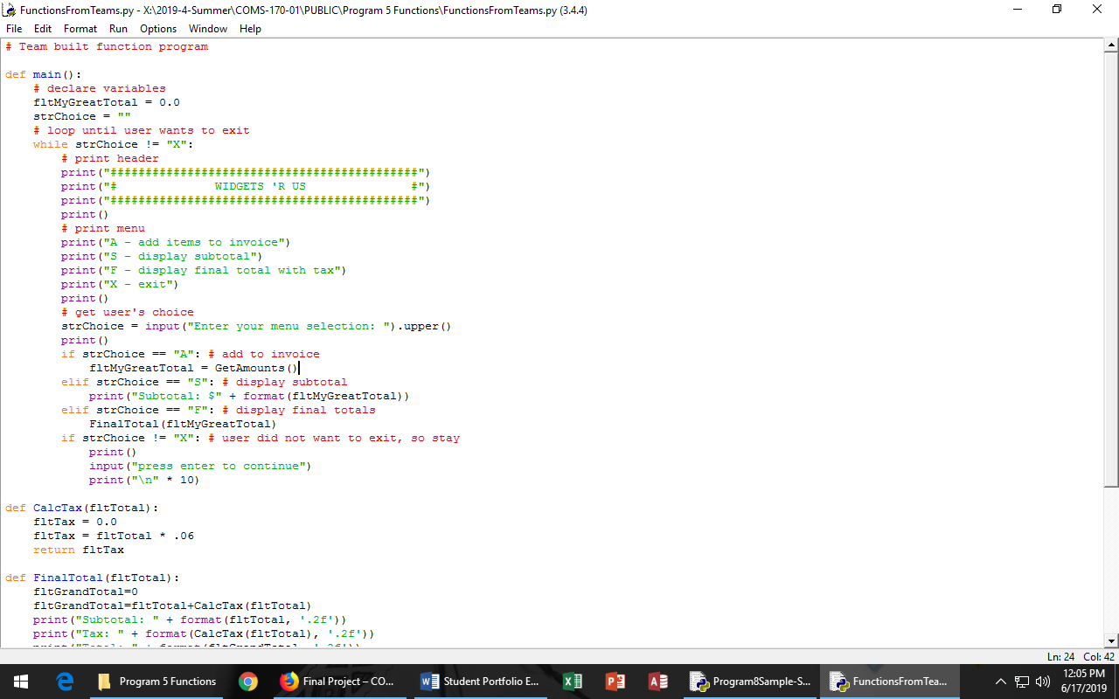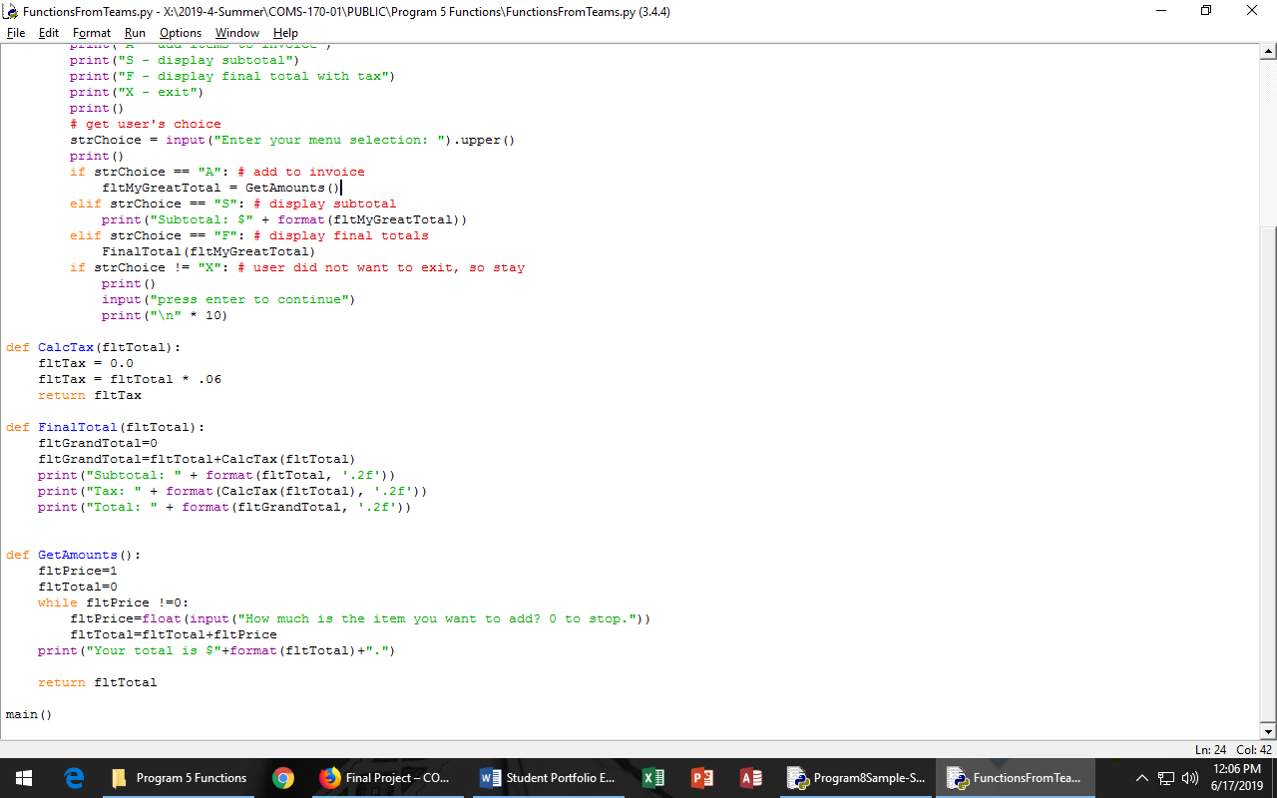

# Certifications

In preparation for a career in Information Technology, I have earned the following certifications:

1. **IC3 Certification – Certiport.** This certification relates to Microsoft Office and basic computing.
2. **MTA: Introduction to Programming – Python**. This certification tests introductory concepts of programming using the Python programming language.
3. **First Aid CPR AED Certification** – American Red Cross. This is basic life saving certification



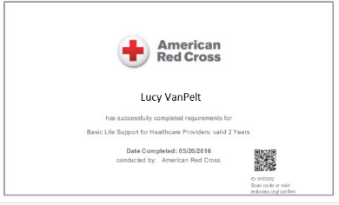

# Student Engagement

1. Attended Careers in IT Presentation that included graduates of degrees at Mott Community College explaining how to work from being a student to being successful in a career.  
   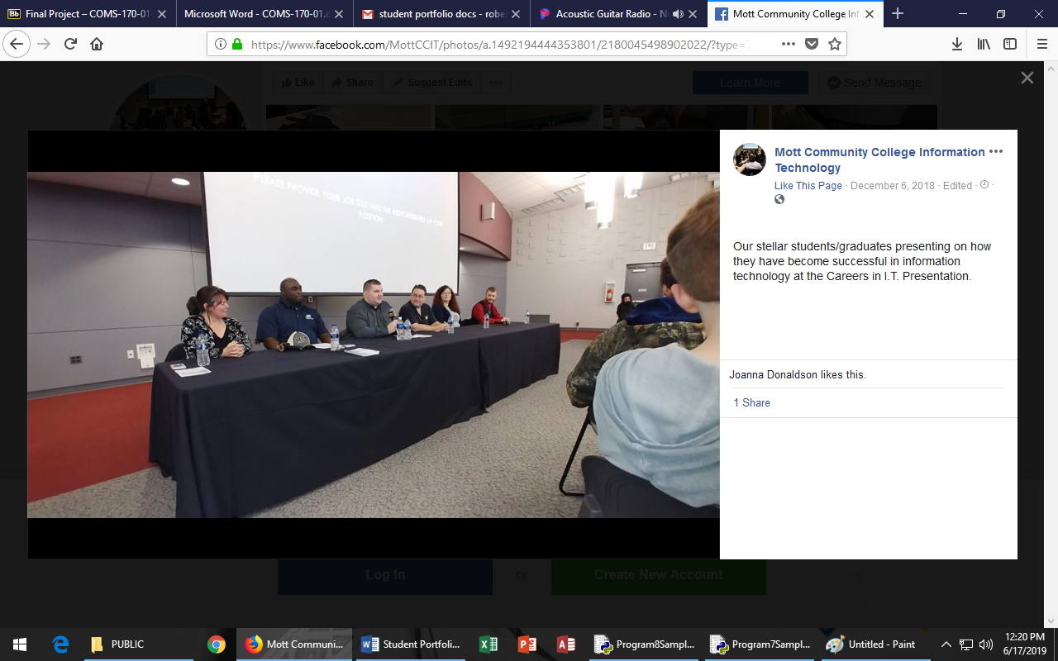
2. Assisted in Mott Library Computer Center helping students with computer programs.  
   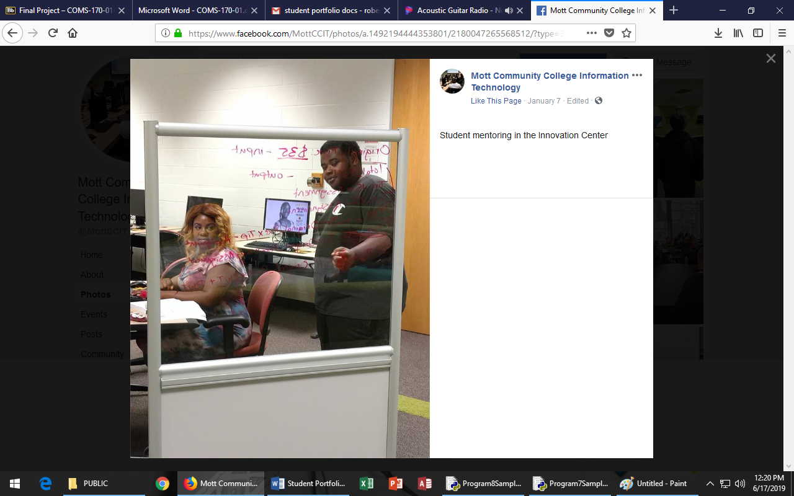
3. Visited the Help Desk at Mott Community College to learn about roles in computer support.
4. Toured the Mott Community College data center learning about the devices running a large scale computer network and the infrastructure needed.   
   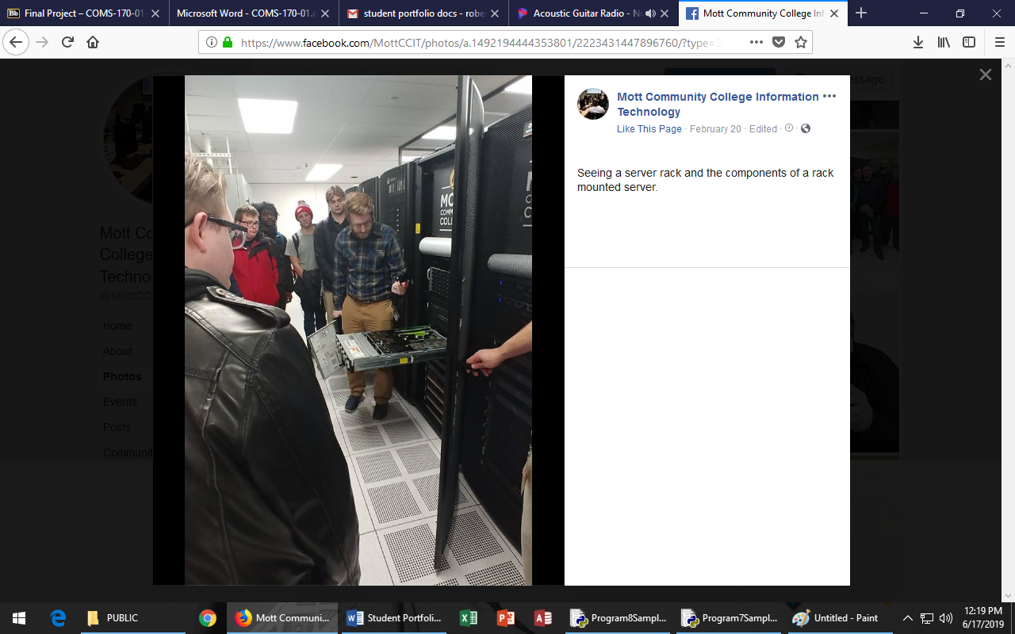

# Extra-curricular activities

Volunteer at annual Millington Summer Festival in Millington, Michigan. Assist with setup and cleanup of small town summer event.

